AUTOMATED EMPLOYEE ONBOARDING&OFFBOARDING SYSTEM

PROJECT REPORT FORMAT
- INTRODUCTION
  - 1.1 Project Overview
  - 1.2 Purpose
- IDEATION PHASE
  - 2.1 Problem Statement
  - 2.2 Empathy Map Canvas
  - 2.3 Brainstorming
- REQUIREMENT ANALYSIS
  - 3.1 Customer Journey Map
  - 3.2 Solution Requirements
  - 3.3 Data Flow Diagram
  - 3.4 Technology Stack
- PROJECT DESIGN
  - 4.1 Problem–Solution Fit
  - 4.2 Proposed Solution
  - 4.3 Solution Architecture
- PROJECT PLANNING & SCHEDULING
  - 5.1 Project Planning
- FUNCTIONAL AND PERFORMANCE TESTING
  - 6.1 Performance Testing
- RESULTS
  - 7.1 Output Screenshots
- ADVANTAGES & DISADVANTAGES
- CONCLUSION
- FUTURE SCOPE
- APPENDIX
- Source Code (if any)
- GitHub Repository Link
- Project Demo Video Link

INTRODUCTION

1.1 Project Overview
The Automated Employee Onboarding & Offboarding System is a low-code application developed on the ServiceNow platform using App Engine Studio, Service Catalog, Flow Designer, and custom tables. The application is designed to automate the complete employee lifecycle by managing onboarding and offboarding requests, approvals, task assignments, notifications, and employee records.
The system enables HR teams and managers to process employee requests through a centralized platform. When an onboarding or offboarding request is submitted through the Service Catalog, it is automatically routed to the manager for approval. Based on the approval decision, the system creates tasks for the HR, IT, and other relevant departments, updates employee lifecycle records, and sends email notifications.
By replacing manual processes with automated workflows, the application reduces processing time, minimizes human errors, improves coordination between departments, and provides better visibility into employee lifecycle activities.
1.2 Purpose
The purpose of this project is to automate employee onboarding and offboarding activities using the ServiceNow platform. The application simplifies employee lifecycle management by reducing manual work, improving communication between departments, and ensuring a standardized workflow for employee-related processes.
The main objectives of this project are:
- Automate employee onboarding and offboarding requests.
- Implement manager approval workflows using Flow Designer.
- Generate HR, IT, and other departmental tasks automatically.
- Send email notifications at each stage of the workflow.
- Maintain employee lifecycle records in a centralized custom table.
- Improve process transparency, tracking, and operational efficiency.
- Enhance data security through role-based access control (ACLs).

2. IDEATION PHASE

Field | Details
Date | 28 June 2026
Team ID | SWTID-2026-2221
Project Name | Automated Employee Onboarding & Offboarding System
Maximum Marks | 4 Marks
2.1 Problem Statement
Many organizations still manage employee onboarding and offboarding through manual processes involving paperwork, emails, and coordination between multiple departments. These manual activities often result in delays, communication gaps, duplicate work, and human errors. Tracking the status of requests and ensuring that every department completes its assigned tasks on time becomes difficult.
The lack of a centralized system also affects process transparency and data consistency. HR teams spend significant time following up on approvals, assigning tasks, and maintaining employee records manually.
To overcome these challenges, this project proposes an automated Employee Onboarding & Offboarding System using the ServiceNow platform. The solution streamlines the entire employee lifecycle by automating request submission, manager approvals, departmental task creation, notifications, and record management through a centralized workflow.

2.2 Empathy Map Canvas
Empathy Map Canvas
An empathy map is a visual tool used to understand the users' needs, challenges, expectations, and experiences. It helps in identifying the problems faced by different stakeholders and designing a solution that effectively addresses their requirements.For the Automated Employee Onboarding & Offboarding System, the empathy map
focuseson employees, HR teams, managers, and department users involved in the employee lifecycle process.

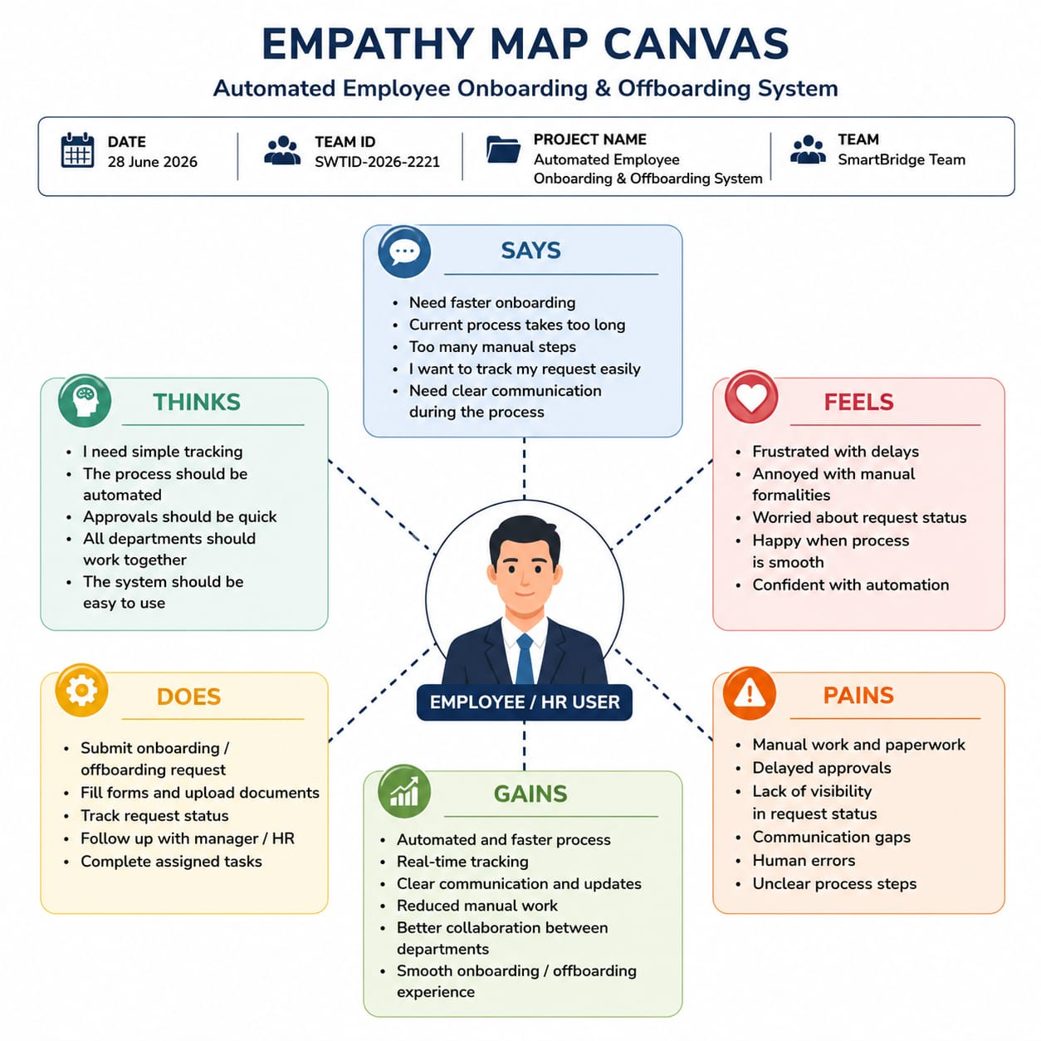

2.3 Brainstorming

Brainstorming is a creative process used to identify problems, generate ideas, and find effective solutions through team collaboration. In this phase, different ideas related to employee lifecycle management were discussed and analyzed to develop an automated solution.
The brainstorming process focused on reducing manual work, improving approval processes, automating departmental tasks, and maintaining employee information securely. The selected ideas helped in designing the Automated Employee Onboarding & Offboarding System using ServiceNow.

S.No | Idea Description | Category
1 | Automate employee onboarding request process | Workflow Automation
2 | Automate employee offboarding request process | Workflow Automation
3 | Create Service Catalog items for onboarding and offboarding | Service Catalog
4 | Generate automatic tasks for HR, IT, Facilities, and Security teams | Task Automation
5 | Configure manager approval workflows using Flow Designer | Approval Management
6 | Send automated email notifications for request updates | Notification System
7 | Maintain employee lifecycle records in a centralized table | Data Management
8 | Implement role-based access control using ACLs | Security
9 | Track onboarding and offboarding status in real time | Process Tracking
10 | Create dashboards and reports for HR monitoring | Reporting
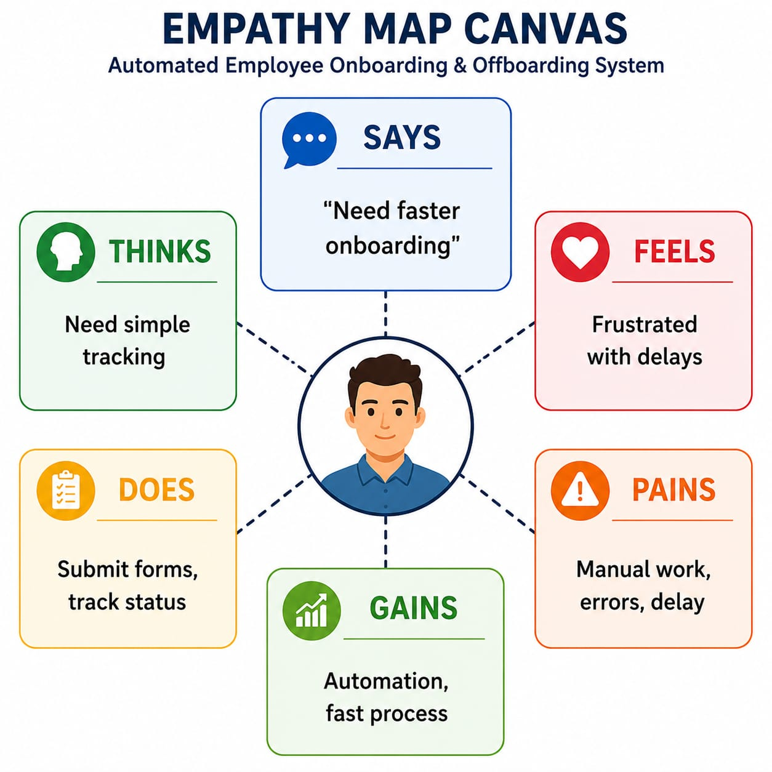

3. REQUIREMENT ANALYSIS  Field | Details
Date | 06 July 2026
Team ID | SWTID-2026-2221
Project Name | Automated Employee Onboarding & Offboarding System
Maximum Marks | 4 Marks

3.1 Customer Journey Map
A Customer Journey Map represents the complete experience of users while interacting with the system. It helps to understand user activities, challenges, expectations, and improvements required at each stage of the process.
For the Automated Employee Onboarding & Offboarding System, the journey map explains how employees, managers, HR teams, and IT teams interact with the ServiceNow application during employee lifecycle activities.

Customer Journey Map Table
Stage | User Action | User Experience | System Response
Request Creation | Employee/HR submits onboarding or offboarding request | Easy request submission | Service Catalog creates request
Request Review | Manager reviews the request | Quick approval process | Approval notification sent
Approval Process | Manager approves/rejects request | Transparent decision making | Flow Designer updates status
Task Assignment | HR, IT, Security receive tasks | Clear responsibilities | Automatic task creation
Process Completion | Departments complete assigned tasks | Smooth completion tracking | Records updated automatically
Notification | Users receive updates | Better communication | Email notifications sent
3.2 Solution Requirements

Solution requirements define the functional and non-functional features required for developing the Automated Employee Onboarding & Offboarding System. These requirements describe what the system should perform and the quality standards that ensure the application is secure, reliable, and efficient.

Functional Requirements

FR No | Functional Requirement | Description
FR-1 | Employee Management | Create and maintain employee lifecycle records in a centralized table.
FR-2 | Onboarding Process | Allow users to submit onboarding requests and automate approval and task creation.
FR-3 | Offboarding Process | Manage employee exit requests with approval workflows and departmental tasks.
FR-4 | Workflow Automation | Automate approvals, notifications, record updates, and task assignments using Flow Designer.
FR-5 | Service Catalog | Provide user-friendly catalog items for employee onboarding and offboarding requests.
FR-6 | Notification System | Send automated email notifications for approvals, tasks, and status updates.
FR-7 | Access Control | Restrict application access using roles and ACLs.

Non-Functional Requirements

NFR No | Requirement | Description
NFR-1 | Usability | The application should provide simple and user-friendly forms.
NFR-2 | Security | Application data should be protected using role-based access control.
NFR-3 | Reliability | Workflows and approvals should execute consistently without errors.
NFR-4 | Performance | Automation should reduce processing time and manual effort.
NFR-5 | Availability | The application should be available through the ServiceNow cloud platform.
NFR-6 | Scalability | The system should support future HR process enhancements.

3.3 Data Flow Diagram
A Data Flow Diagram (DFD) is a graphical representation of how data moves through a system. It describes the flow of information between users, processes, and data storage components. The DFD helps to understand how requests are submitted, processed, stored, and managed within the Automated Employee Onboarding & Offboarding System.
The DFD of this project represents the interaction between employees, managers, HR teams, IT teams, Security teams, ServiceNow workflows, and the Employee Lifecycle database.
3.4 Technology Stack
The Automated Employee Onboarding & Offboarding System is developed using the ServiceNow platform and its low-code development tools. The technology stack includes ServiceNow App Engine Studio for application development, Service Catalog for user requests, Flow Designer for workflow automation, and custom tables for employee data management.
The selected technologies help in creating a secure, scalable, and automated employee lifecycle management solution.

Component | Technology Used | Description
User Interface | ServiceNow App Engine Studio | Used to create application forms, pages, and user interfaces.
Application Development | App Engine Studio | Used for building custom low-code applications.
Database | ServiceNow Custom Tables | Stores employee, onboarding, and offboarding records.
Request Management | Service Catalog | Provides onboarding and offboarding request forms.
Workflow Automation | Flow Designer | Automates approvals, tasks, notifications, and record updates.
Approval Management | Ask for Approval Action | Handles manager approval and rejection process.
Notifications | ServiceNow Email Notifications | Sends automated emails to users and departments.
Security | Roles and ACLs | Provides role-based access control and data security.
Platform | ServiceNow Personal Developer Instance (PDI) | Cloud environment used for development and testing.

4. PROJECT DESIGN

4.1 Problem–Solution Fit

Field | Details
Date | 06 July 2026
Team ID | SWTID-2026-2221
Project Name | Automated Employee Onboarding & Offboarding System
Maximum Marks | 2 Marks

Introduction:
4.1 Problem–Solution Fit

Problem–Solution Fit identifies whether the proposed solution effectively addresses the problems faced by users. It helps in understanding user challenges and designing a system that provides meaningful improvements.
In the existing employee management process, organizations face difficulties such as manual documentation, delayed approvals, lack of tracking, and communication gaps between departments. The proposed Automated Employee Onboarding & Offboarding System solves these challenges by providing a centralized ServiceNow-based platform with automated workflows, approvals, notifications, and task management.
Section | Description
Customer Segment(s) | Employees, HR teams, Managers, IT teams, Security teams
Jobs-to-be-done | Employee onboarding, offboarding, approvals, task completion, record management
Triggers | New employee joining, employee resignation, employee exit process
Problems Before Solution | Manual forms, email communication, approval delays, lack of tracking
Customer Expectations | Faster processing, transparency, easy tracking, secure data management
Existing Solutions | Manual HR processes, spreadsheets, email-based communication
Root Cause | No centralized system and limited automation
Proposed Solution | ServiceNow application with Service Catalog, Flow Designer, approvals, notifications, custom tables, and ACL security

Field | Details
Date | 06 July 2026
Team ID | SWTID-2026-2221
Project Name | Automated Employee Onboarding & Offboarding System
Maximum Marks | 2 Marks

4.2 Proposed Solution
The proposed solution is to develop an Automated Employee Onboarding & Offboarding System using the ServiceNow platform. The system provides a centralized solution to manage employee lifecycle activities by automating request submission, approval processes, departmental task assignments, notifications, and employee record management.
The application is developed using ServiceNow App Engine Studio, Service Catalog, Flow Designer, custom tables, and Access Control Lists (ACLs). Employees or HR users can submit onboarding and offboarding requests through catalog items. These requests are automatically processed through workflows where managers can approve or reject them.
After approval, the system automatically creates tasks for HR, IT, and Security teams. Email notifications are generated to keep stakeholders informed about request status and task completion. Employee details are stored securely in the Employee Lifecycle custom table for future tracking and reporting.

Proposed Solution Template

Parameter | Description
next | Organizations face delays and errors due to manual employee onboarding and offboarding processes.
Idea / Solution Description | Develop a ServiceNow-based application to automate employee lifecycle management using workflows and approvals.
Novelty / Uniqueness | Integrates request management, approvals, task automation, notifications, and security in one platform.
Social Impact / Customer Satisfaction | Provides faster onboarding, smoother offboarding, and improves employee experience.
Business Model | Can be used as an enterprise HR workflow solution with customization and maintenance services.
Scalability | Can be extended with leave management, payroll integration, asset management, and other HR services.

Field | Details
Date | 06 July 2026
Team ID | SWTID-2026-2221
Project Name | Automated Employee Onboarding & Offboarding System
Maximum Marks | 4 Marks
4.3 Solution Architecture
Solution Architecture describes the structure and interaction between different components of the Automated Employee Onboarding & Offboarding System. It explains how users interact with the ServiceNow application, how requests are processed through workflows, how data is stored, and how notifications are generated.
The architecture is designed using ServiceNow low-code development components including Service Catalog, Flow Designer, custom tables, approval workflows, notification services, and security controls. The architecture ensures automation, scalability, reliability, and secure management of employee lifecycle processes.

Architecture Components
Component | Description
Service Portal | Provides user interface for submitting onboarding and offboarding requests.
Service Catalog | Contains catalog items for employee lifecycle requests.
Flow Designer | Automates workflows, approvals, task creation, and record updates.
Approval Engine | Manages manager approval and rejection process.
Custom Tables | Stores employee lifecycle information.
Notification Service | Sends automated email notifications.
Security Layer | Uses roles and ACLs to protect application data.

5. PROJECT PLANNING & SCHEDULING
5.1 Project Planning
Introduction
Project planning defines the activities, timeline, and tasks required to successfully develop the Automated Employee Onboarding & Offboarding System. The project was divided into multiple sprints to manage development activities effectively. Each sprint focused on implementing specific functionalities such as employee management, workflow automation, approvals, notifications, security, and testing.

Sprint Planning Table

Sprint | Activity | User Story / Task | Story Points | Priority
Sprint-1 | Employee Management | Create Employee Lifecycle Table | 2 | High
Sprint-1 | Employee Management | Create Employee Forms | 2 | High
Sprint-1 | Service Catalog | Create Onboarding Request Catalog Item | 3 | High
Sprint-1 | Workflow Automation | Develop Onboarding Flow | 5 | High
Sprint-1 | Approval Process | Configure Manager Approval | 3 | High
Sprint-1 | Notifications | Configure Email Notifications | 2 | Medium
Sprint-2 | Offboarding Process | Create Offboarding Workflow | 5 | High
Sprint-2 | Task Automation | Create HR, IT, Security Tasks | 5 | High
Sprint-2 | Security | Configure Roles and ACLs | 3 | Medium
Sprint-2 | Testing | Validate Complete Application | 2 | High

Project Schedule
Sprint | Duration | Major Deliverables
Sprint-1 | 6 Days | Employee Management, Onboarding Workflow, Approvals, Notifications
Sprint-2 | 6 Days | Offboarding Workflow, Security, Testing and Validation
6. FUNCTIONAL AND PERFORMANCE TESTING
6.1 Performance Testing
Introduction
Performance testing is performed to evaluate the efficiency, reliability, and response time of the Automated Employee Onboarding & Offboarding System. The testing ensures that workflows, approvals, notifications, and database operations perform effectively under different conditions.
The ServiceNow application was tested to verify that employee requests are processed correctly, workflows execute without delays, and users receive proper responses during onboarding and offboarding activities.
Performance Testing Table

Test Scenario | Expected Result | Status
Submit Employee Onboarding Request | Request should be created successfully | Pass
Submit Employee Offboarding Request | Offboarding request should be created successfully | Pass
Manager Approval Process | Approval should update request status correctly | Pass
Flow Designer Execution | Automated workflow should execute successfully | Pass
Task Creation | HR, IT, and Security tasks should be generated automatically | Pass
Email Notification | Notifications should be sent to respective users | Pass
Employee Record Update | Employee lifecycle table should update correctly | Pass
Access Control Testing | Only authorized users should access records | Pass

Testing Result
The performance testing results show that the application successfully handles employee lifecycle processes with proper workflow execution, data management, and notification delivery. The automated system reduces manual processing time and improves the overall efficiency of employee onboarding and offboarding activities.

7. RESULTS
Introduction:
7.1 Output Screenshots
The Automated Employee Onboarding & Offboarding System was successfully implemented using the ServiceNow platform. The developed application provides automated employee request submission, approval workflows, task assignments, notifications, and employee lifecycle record management.
The following screenshots demonstrate the major outputs and functionalities achieved during the implementation of the project.
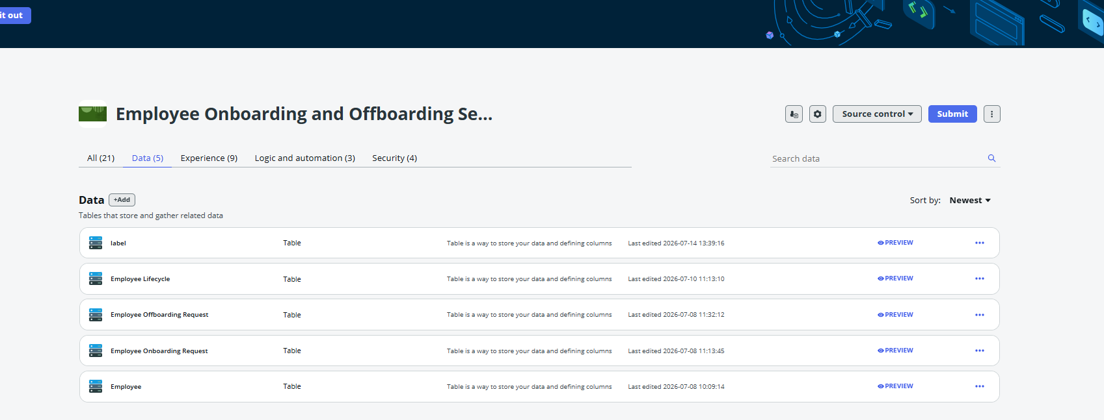
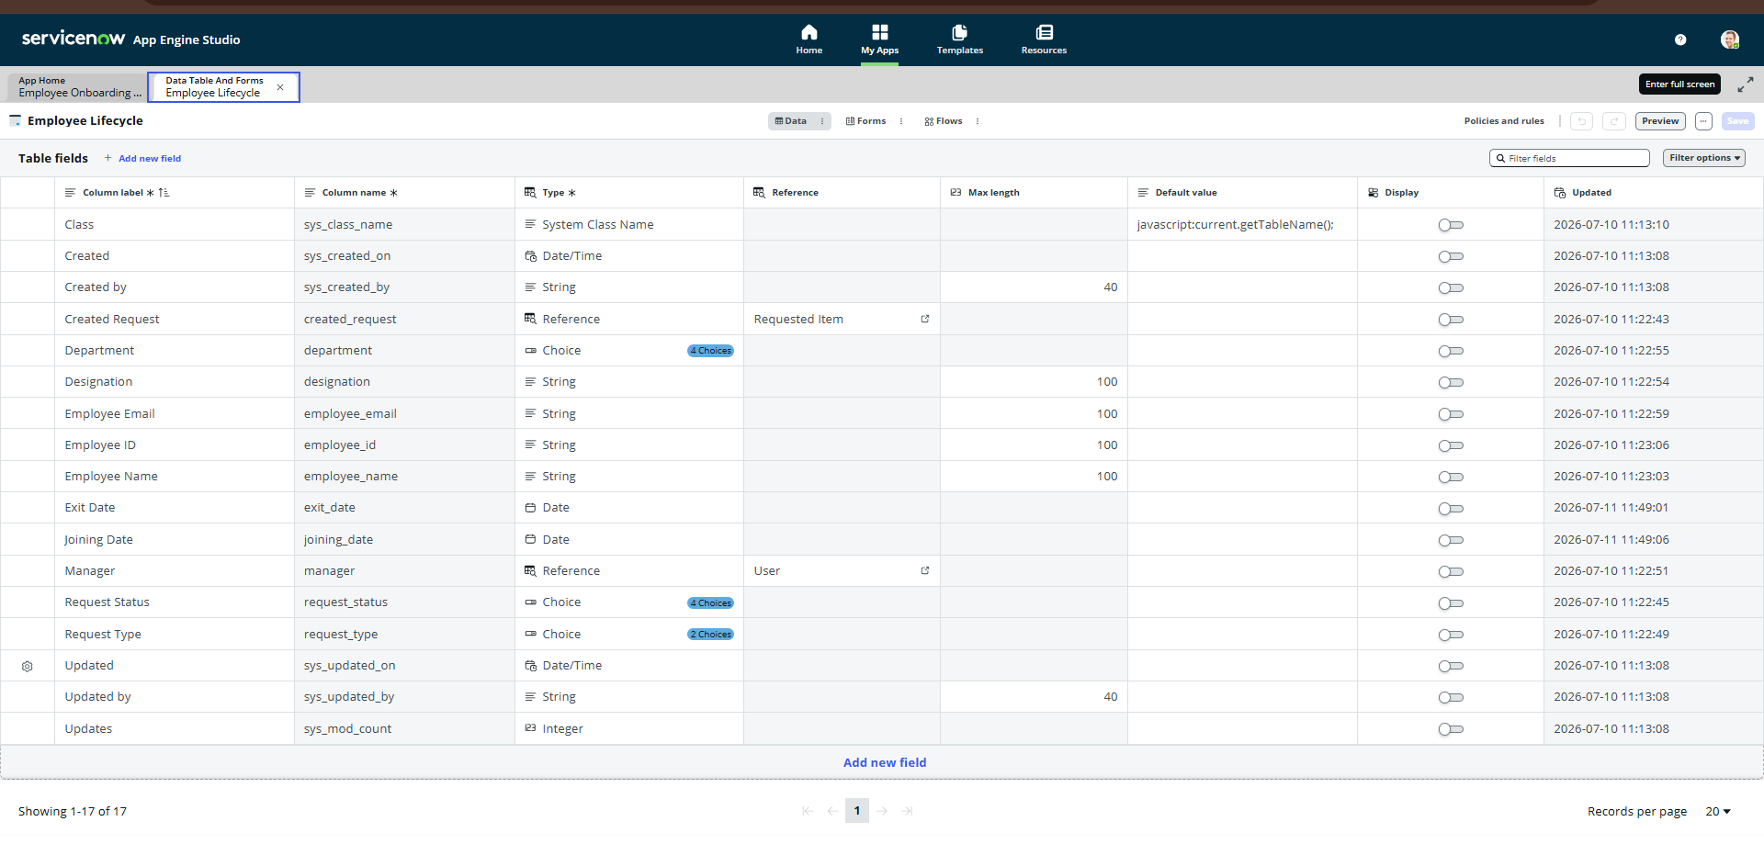
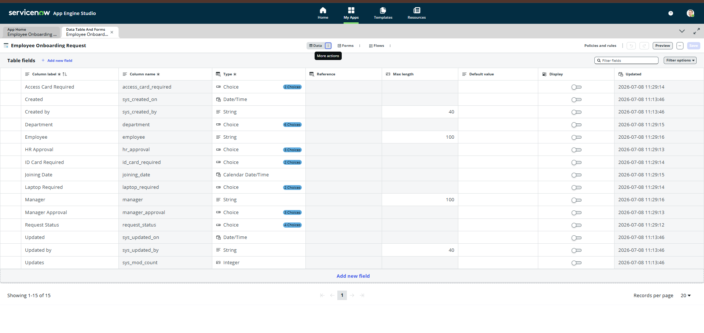

Figure 3: ServiceNow Employee Management Application Dashboard
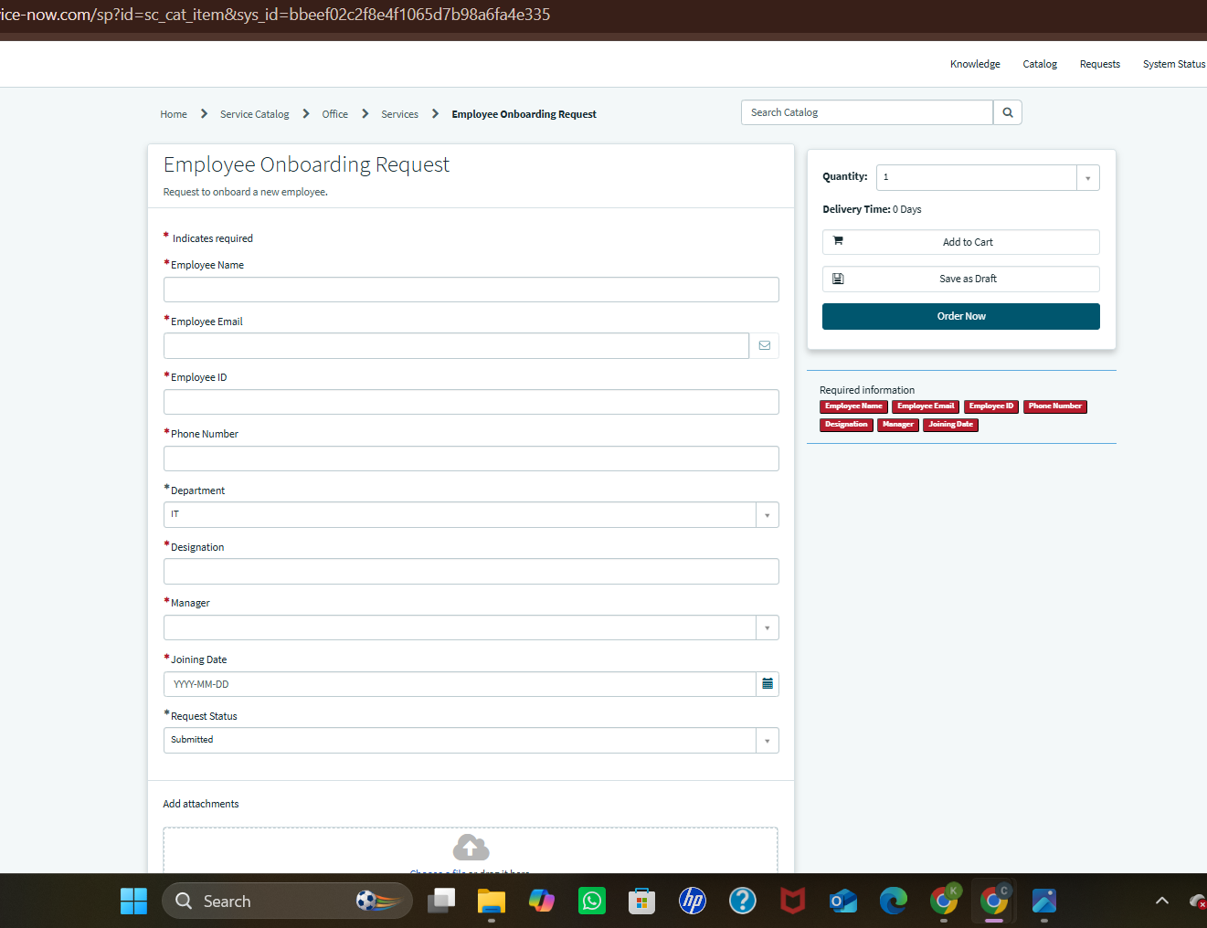
Figure 4: Employee Onboarding Request Form
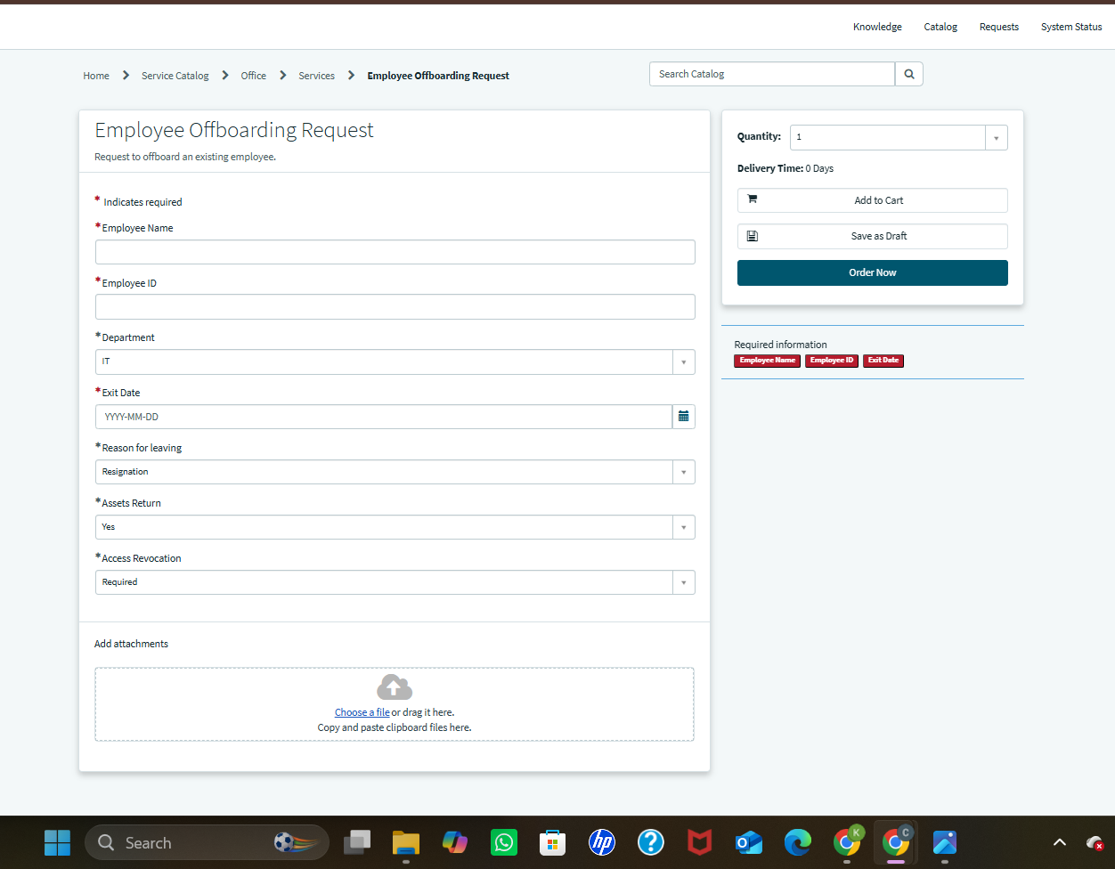
Figure 5: Employee Offboarding Request Form

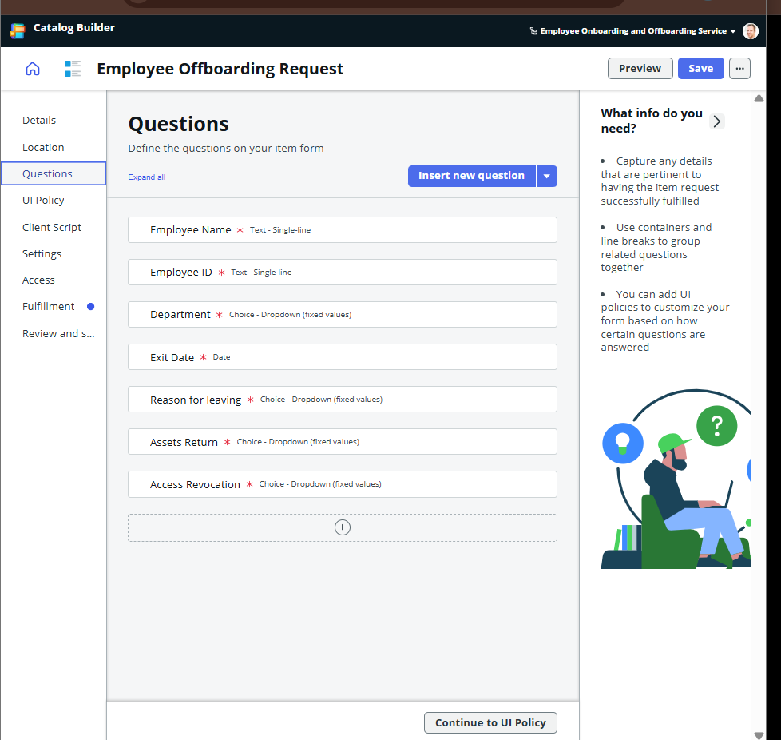

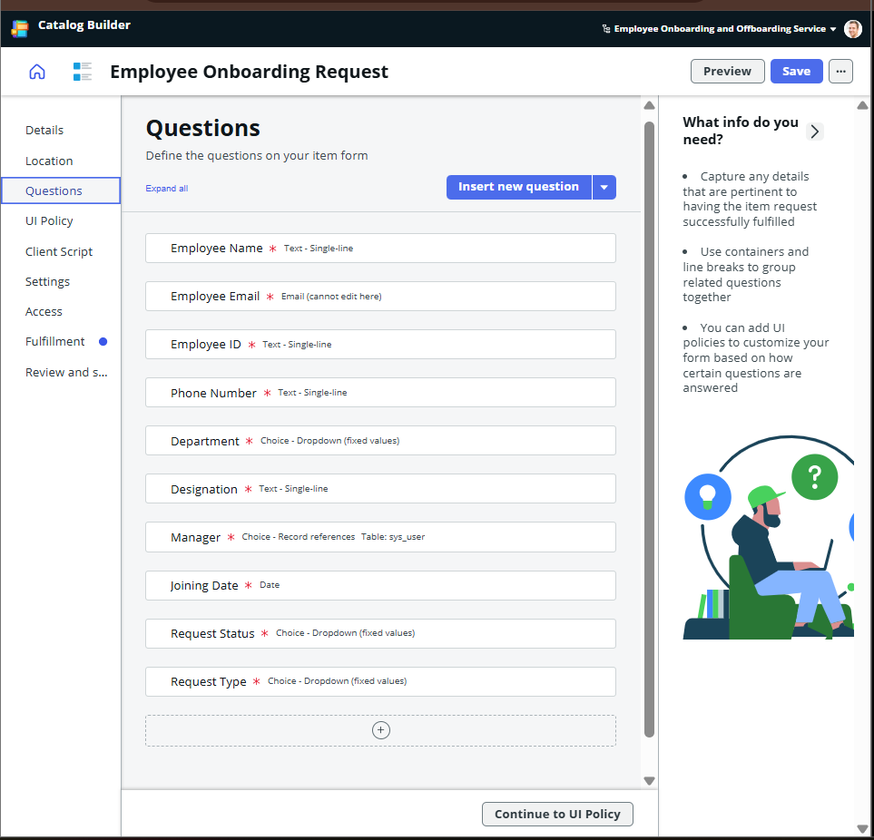
Figure 6: Catalog Varaibles Questions
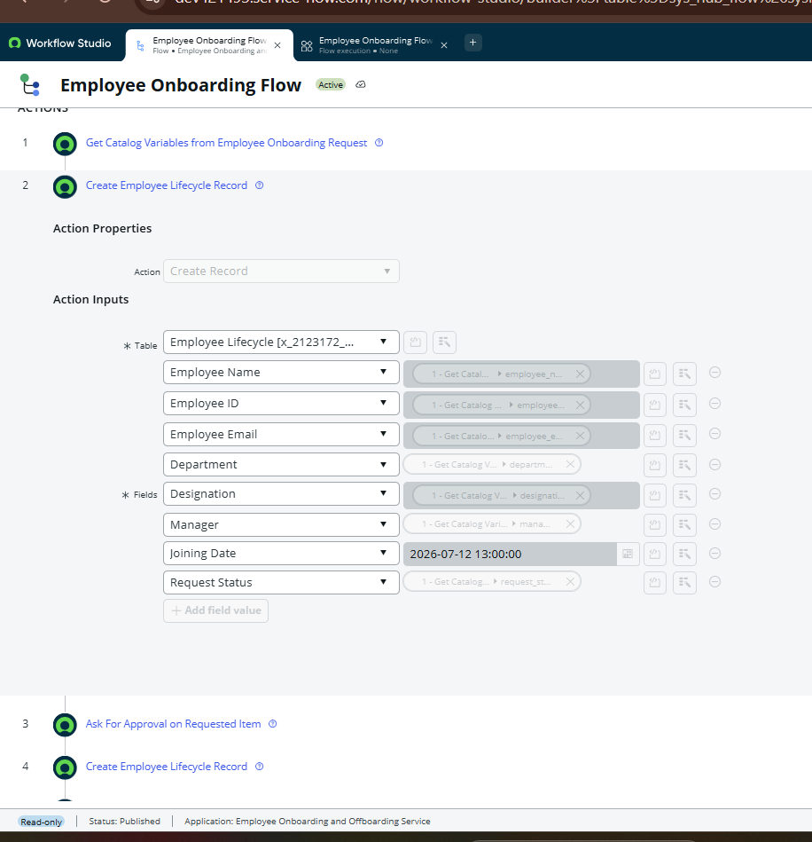
Figure 7: Employee Lifecycle Table Record
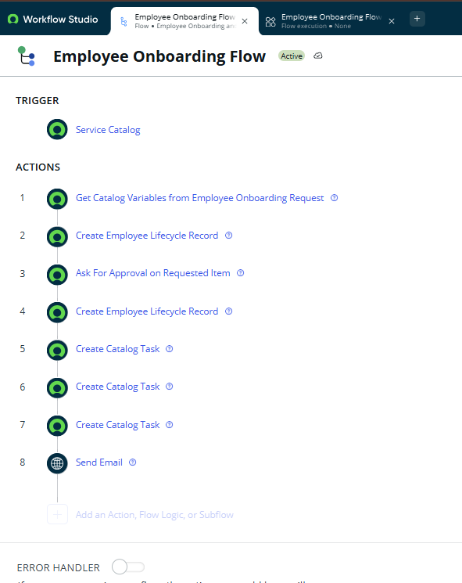
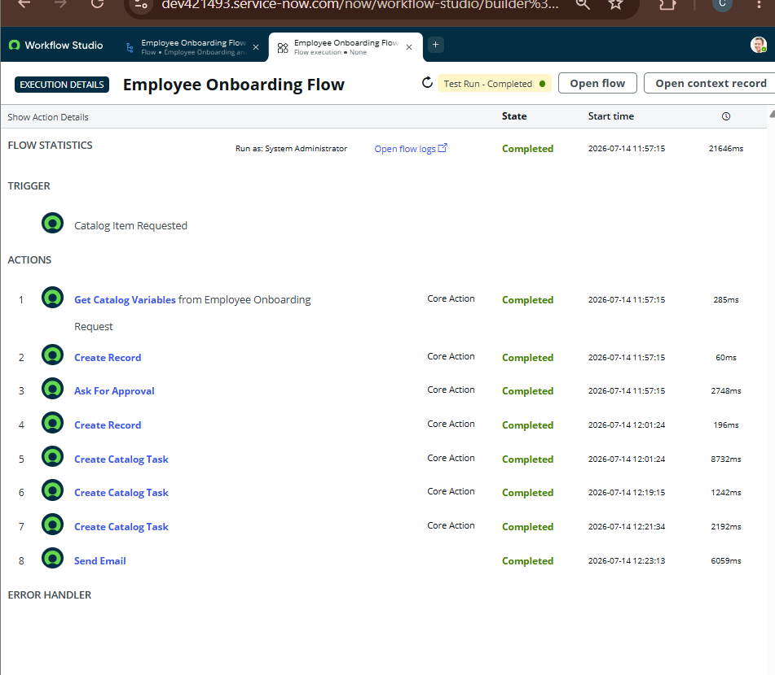

Figure 8: Employee Onboarding Automation Flow

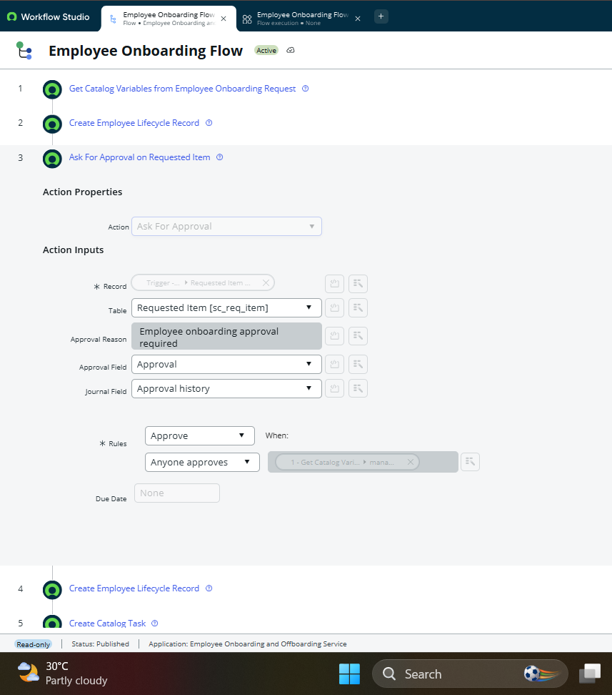
Figure 9: Manager Approval Workflow
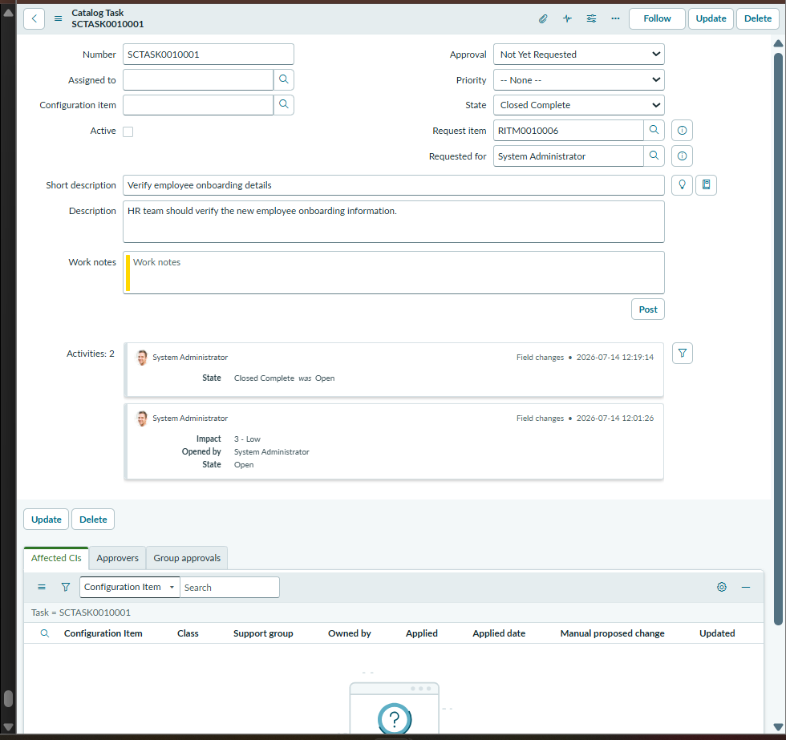
Figure 10: HR, IT and Security Task Creation
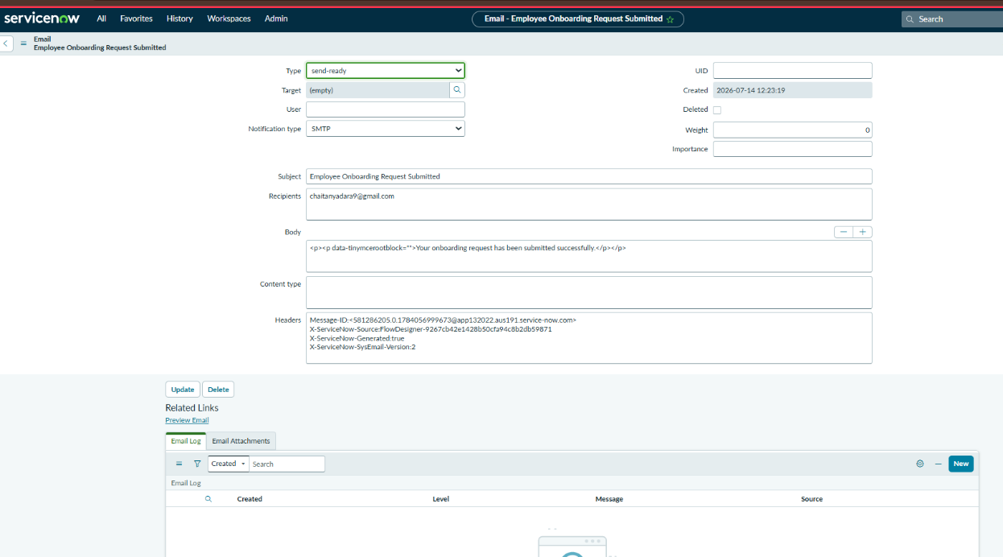
Figure 11: Automated Email Notification
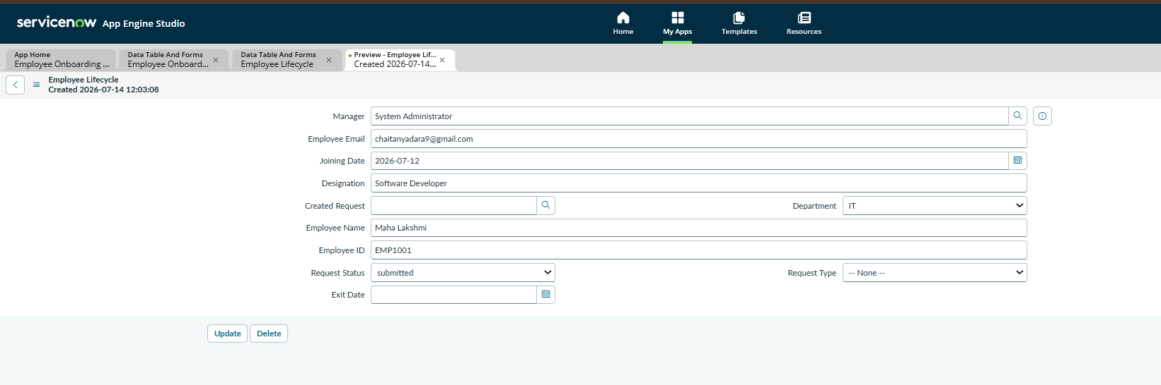
Figure 12: Completed Employee Lifecycle Record

8. ADVANTAGES & DISADVANTAGES
Advantages of Automated Employee Onboarding & Offboarding System
Advantages

1. Automated Employee Lifecycle Management
The system automates employee onboarding and offboarding processes, reducing manual paperwork and administrative effort.
2. Centralized Employee Data
Employee information and lifecycle records are stored in a centralized ServiceNow database, making data management easier and more organized.
3. Workflow Automation
Flow Designer automates approvals, task creation, notifications, and record updates, improving process efficiency.
4. Faster Approval Process
Manager approvals are handled electronically, reducing delays and improving communication between departments.
5. Automatic Task Assignment
HR, IT, and Security tasks are automatically created after approval, ensuring timely completion of responsibilities.
6. Improved Communication
Automated email notifications keep employees and stakeholders updated about request status and progress.
7. Enhanced Security
Roles and Access Control Lists (ACLs) ensure that only authorized users can access or modify application data.
8. Reduced Human Errors
Automation minimizes manual data entry mistakes and improves process accuracy.
9. Better Tracking and Transparency
Users can track onboarding and offboarding requests throughout the complete lifecycle process.
10. Scalability
The application can be extended with additional HR processes such as leave management, asset management, and payroll integration.

Disadvantages
1. ServiceNow Platform Dependency
The application depends on the ServiceNow platform and requires a ServiceNow environment to operate.
2. Initial Configuration Effort
Creating tables, workflows, approvals, notifications, and security rules requires initial development time.
3. Training Requirement
Users may require training to effectively use the application features.
4. Customization Complexity
Advanced customizations and integrations may require additional ServiceNow development knowledge.
5. Internet Dependency
As a cloud-based application, the system requires a stable internet connection.
6. Maintenance Requirement
Regular updates, workflow monitoring, and security reviews are required for smooth operation.

9. CONCLUSION
Conclusion
The Automated Employee Onboarding & Offboarding System successfully automates the employee lifecycle management process using the ServiceNow platform. The application reduces manual effort by automating request submission, manager approvals, departmental task assignments, notifications, and employee record management.
By using ServiceNow App Engine Studio, Service Catalog, Flow Designer, custom tables, and Access Control Lists (ACLs), the system provides a centralized, secure, and efficient solution for managing employee onboarding and offboarding activities.
The project improves communication between HR, managers, IT, and other departments by providing real-time tracking and automated workflows. It minimizes errors, reduces processing time, and ensures that employee lifecycle activities are completed in a structured manner.
Overall, the developed system provides a scalable and reliable solution that enhances organizational efficiency and improves the employee experience.

10. FUTURE SCOPE
Future Scope
The Automated Employee Onboarding & Offboarding System developed on the ServiceNow platform has significant opportunities for future enhancements. The current system automates employee requests, approvals, notifications, task assignments, and lifecycle tracking. In the future, the application can be extended into a complete Human Resource Management solution by integrating additional features and advanced technologies.
Future Enhancements
1. Leave Management Integration
The system can be enhanced with leave request and approval workflows to manage employee attendance and leave balances.
2. Payroll Integration
Integration with payroll systems can automate salary processing and employee status updates.
3. Asset Management Integration
The system can track company assets such as laptops, ID cards, and software licenses during onboarding and asset returns during offboarding.
4. Employee Self-Service Portal
Employees can access a self-service portal to submit requests, track status, update profiles, and view notifications.
5. Advanced Dashboards and Reports
Real-time dashboards can be created for HR teams to analyze onboarding trends, approval times, and department performance.
6. AI-Based Automation
Artificial Intelligence capabilities can be integrated to predict delays, recommend actions, and automate repetitive HR activities.
7. External System Integration
The application can be connected with Active Directory, email systems, payroll software, and third-party HR applications.
8. Mobile Application Support
Mobile access can allow managers and employees to approve requests and monitor activities from anywhere.
9. Document Management
Employee documents such as offer letters, identity proofs, and exit documents can be stored securely within the system.
10. Multi-Department Expansion
The workflow can be extended to Finance, Administration, Facilities, and other departments for complete organizational automation.
11. APPENDIX
Appendix
The appendix contains additional information related to the project, including source code details, repository information, and project demonstration links.

Source Code
The project is developed using the ServiceNow platform. The application configuration includes ServiceNow App Engine Studio components, custom tables, Service Catalog items, Flow Designer workflows, approval processes, notifications, and security configurations.
The complete project configuration and related documents can be accessed through the project repository.

GitHub Repository Link
GitHub Link:
https://github.com/236K1A0513/Automated-Employee-Onboarding-Off-boarding-System

Project Demo Link
Project Demo Video Link:
The demo video explains the application workflow, including employee request submission, approval process, automated task creation, notifications, and final record updates.

Project Details
Field | Details
Project Name | Automated Employee Onboarding & Offboarding System
Platform | ServiceNow
Development Tool | App Engine Studio
Automation Tool | Flow Designer
Database | ServiceNow Custom Tables
Security | Roles and ACLs

S.No | Team Member Name
1 | D.Chaitanya Kanka Maha Lakshmi(Team Lead)
2 | M.Gayatri Varalakshmi(Member)
3 | K.Bhanu(Member)
4 R.Abhinash(Member)
5 p.Siva Gangadhar Mouli(Member)

